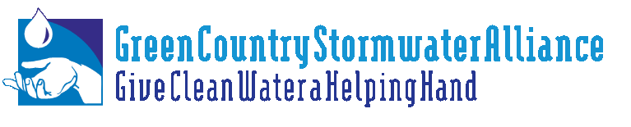
INCOG OKR04 FACT SHEET FOR GCSA

O&M TEXT FROM EXISTING OKR04 GENERAL PERMIT FOR SMALL MS4s

The following text is copied verbatim from the existing OKR04 General Permit that expired February 2010 but is still in effect pending finalization of revisions in 2012. All passages related to OKR04 requirements for developing an Operation and Maintenance (O&M) Program from the Good Housekeeping Minimum Control Measure (MCM) section have been pasted below. References about education requirements have not been copied because INCOG’s employee training for GCSA covers all 6th MCM requirements.

PART IV.C MINIMUM CONTROL MEASURES

6. Pollution Prevention/Good Housekeeping For MS4 Operations

a. Permit Requirements
(1) Develop and implement an operation and maintenance program that includes a training component and has the ultimate goal of preventing or reducing pollutant runoff from MS4 operations;

b. Rationale
You must document your decision process for the development of a pollution prevention/good housekeeping program for MS4 operations. Your rationale must address your overall pollution prevention/good housekeeping program and the individual BMPs, measurable goals, and responsible persons for your program. The rationale must include the following information, at a minimum:

(1) Describe your operation and maintenance program to prevent or reduce pollutant runoff from your MS4 operations. You must specifically list the MS4 operations that are impacted by this program.

(2) Provide a list of industrial facilities you own or operate that are subject to the DEQ Multi-Sector General Permit or individual OPDES or NPDES permits for discharges of storm water associated with industrial activity that ultimately discharge to your SMS4. Include the authorization number or a copy of the Industrial NOI form for each facility.
…
(4) Your program description must specifically address the following areas:
(a) Maintenance activities, maintenance schedules, and long-term inspection procedures for controls to reduce floatables and other pollutants to your SMS4.
(b) Controls for reducing or eliminating the discharge of pollutants from streets, roads, highways, parking lots, maintenance and storage yards, waste transfer stations, fleet or maintenance shops with outdoor storage areas, and salt/sand storage locations and snow disposal areas you operate.
(c) Procedures for the proper disposal of waste removed from your MS4 and your MS4 operations, including dredge spoil, accumulated sediments, floatables, and other debris.
(d) Procedures to ensure that new flood management projects are assessed for impacts on water quality and existing projects are assessed for incorporation of additional water quality protection devices or practices.

